How to set-up practice Lab with KALI Linus and Oracle Virtual Machine for Beginners

INTRODUCTION AND OBJECTIVE
This report documents the setup of a cybersecurity and ethical hacking practice lab using VirtualBox, with Kali Linux as the attacking machine on an isolated NAT Network (10.0.0.0/24).
Tools Used:
- 7-Zip: Used to unzipped downloaded files.
- Oracle VirtualBox: This is the Virtual Machine used to run our operating system.
- Kali Linux: Operating System

LAB REQUIREMENTS CHECKLIST
Tick each item once it is done and its evidence is inserted below.
- VirtualBox installed (latest recommended version)
- Kali Linux set up as the attacking machine
- Network configured in subnet 10.0.0.0/24
- NAT Network created with 10.0.0.0/24
- Clipboard and file drag/drop enabled in VM settings
- Shared folder enabled, with /downloads shared from the host
- Kali Linux IP address set to 10.0.0.2/24
- Kali Linux has full Internet access

IMPLEMENTATION STEPS AND EVIDENCE
Evidence: Showing all tools downloaded; 7-Zip download, VirtualBox download and Kali download
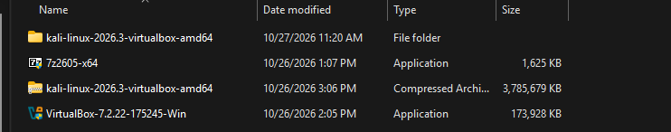

DOWNLOADED TOOLS
7-Zip was installed from 7-zip.org.
VirtualBox was downloaded from virtualbox.org and installed with default options.
The Kali Linux virtual machine image was downloaded from kali.org/get-kali, and extracted with 7-Zip which was then imported into VirtualBox.

CONFIGURING NAT NETWORK (10.0.0.0/24)
A NAT Network was created in VirtualBox with the IPv4 prefix 10.0.0.0/24 and DHCP [enabled/disabled]. Network name: Network.

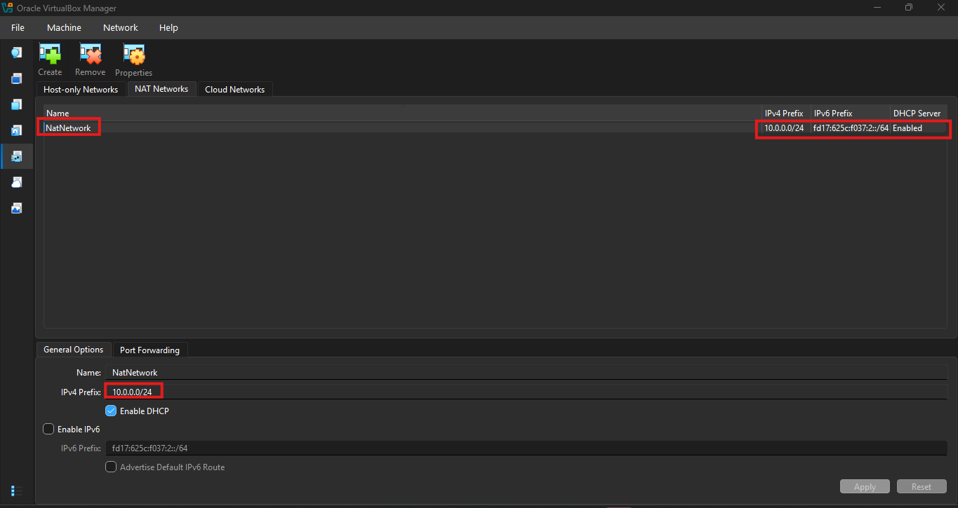
Evidence: NAT Networks list showing the new network and its 10.0.0.0/24 prefix
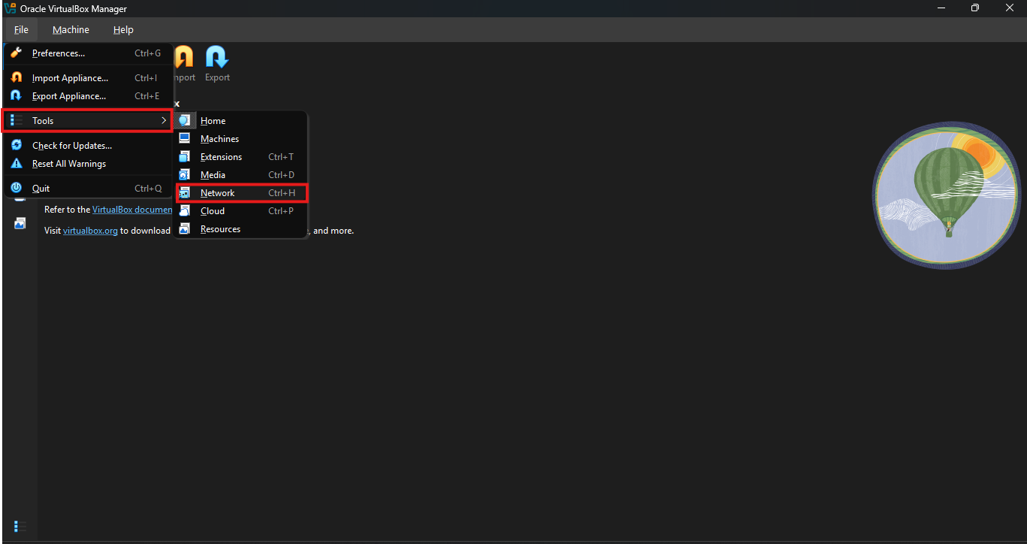
Evidence: NAT Network Details/Settings Window

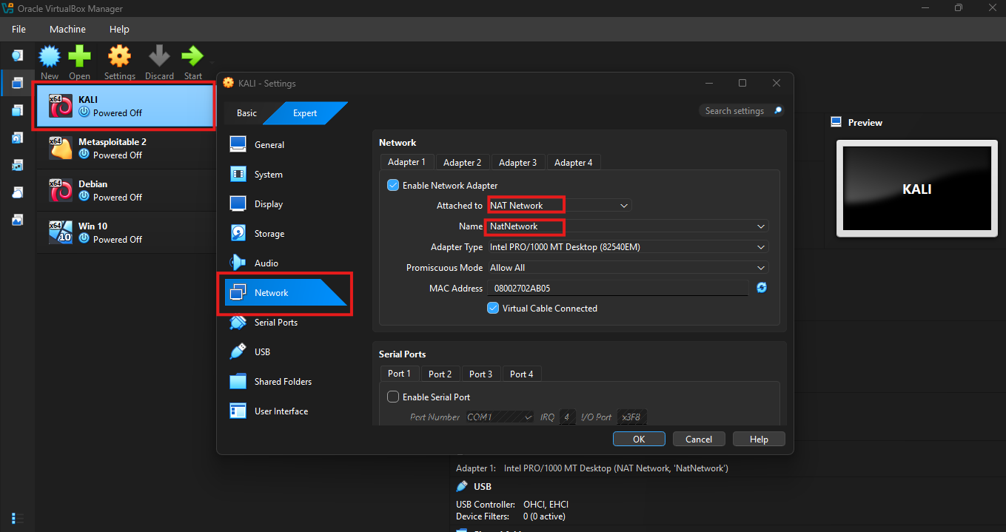
Evidence: VM network settings with the adapter attached to the NAT Network

SET UP THE IP CONFIGURATION OF KALI LINUX
Network configuration screen of where the Static IP was set
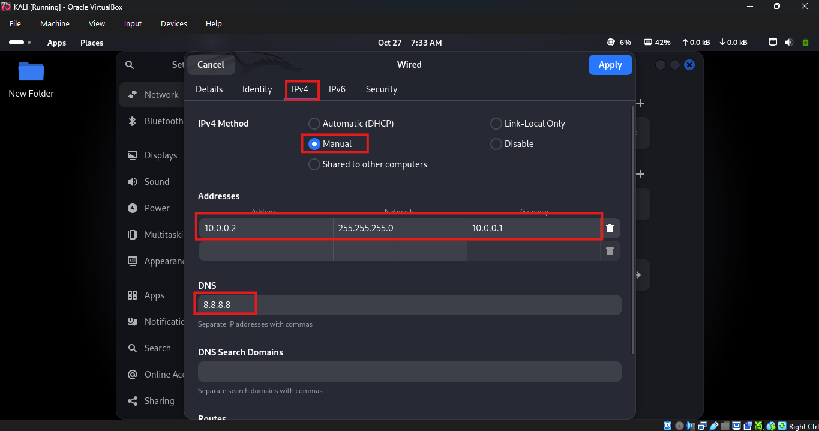
Kali was given the Static Address 10.0.0.2. Gateway: 10.0.0.1. DNS: 8.8.8.8.

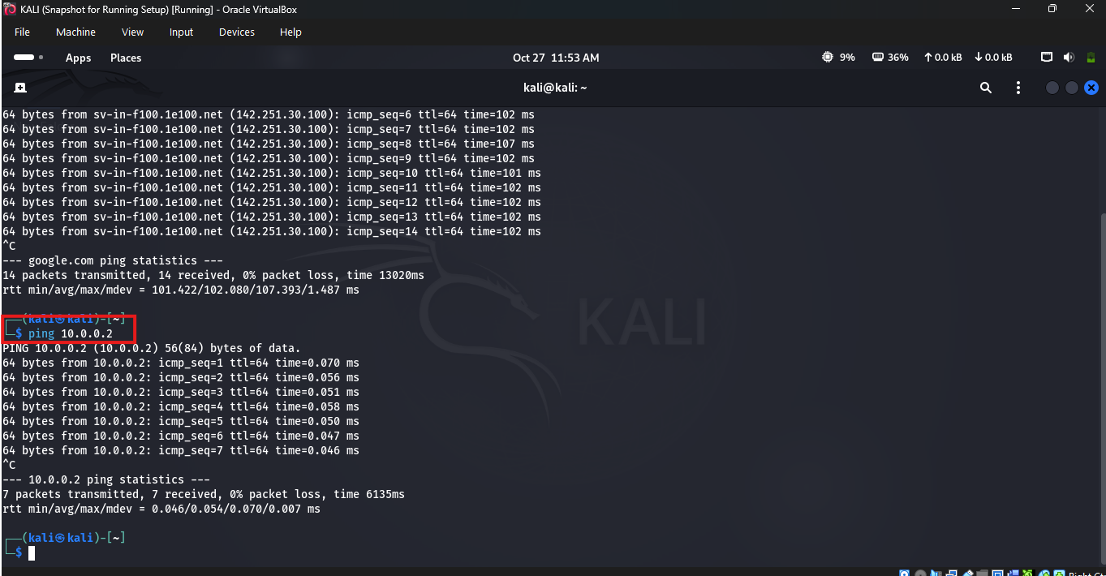
Evidence: Terminal output of ping 10.0.0.2 showing replies (Kali Terminal)

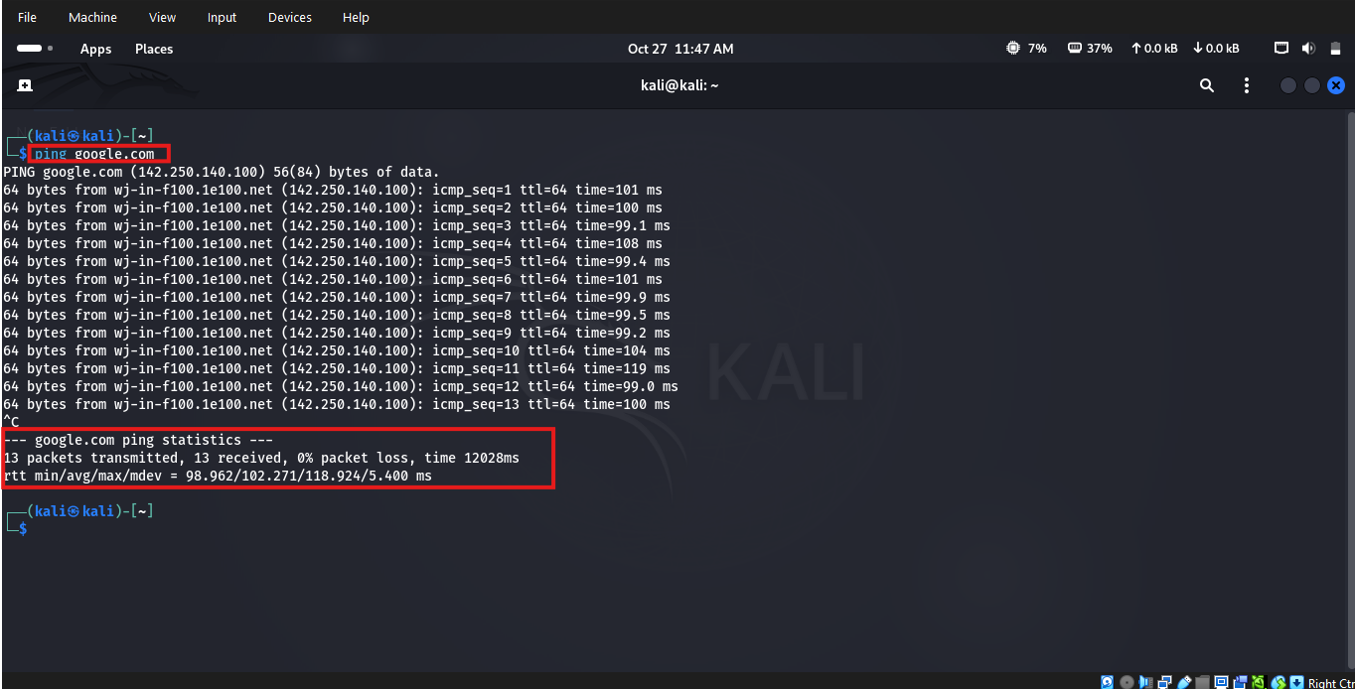
Evidence: Terminal output of ping google.com showing replies (Kali Terminal)

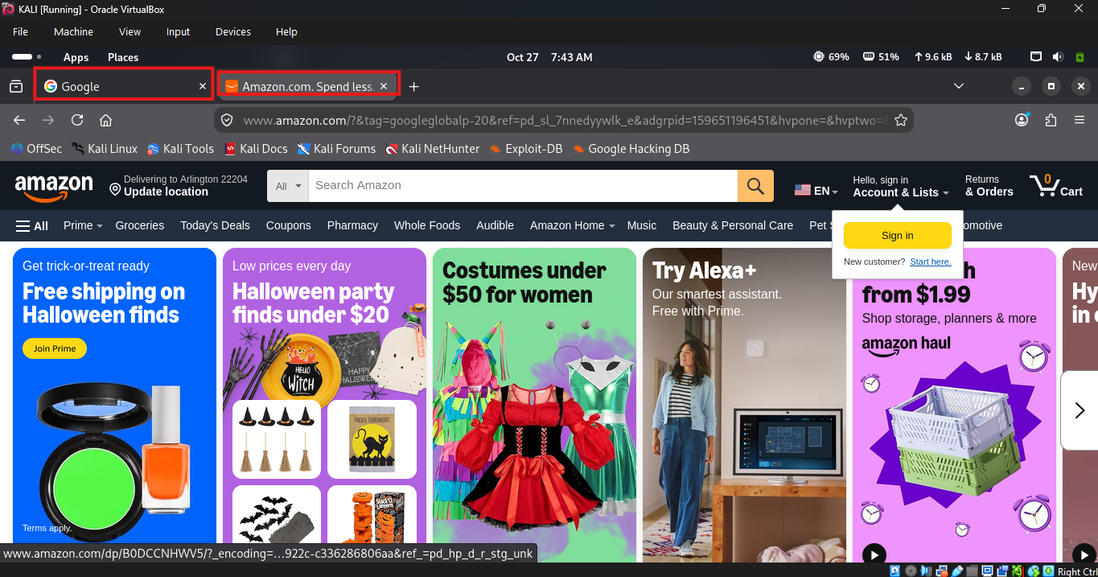
Evidence: GUI browsing Google and Amazon after configuration (Firefox)

TAKE A SNAPSHOT OF THE VM
A snapshot named was taken after a working configuration was confirmed, so the lab can be restored if something breaks.
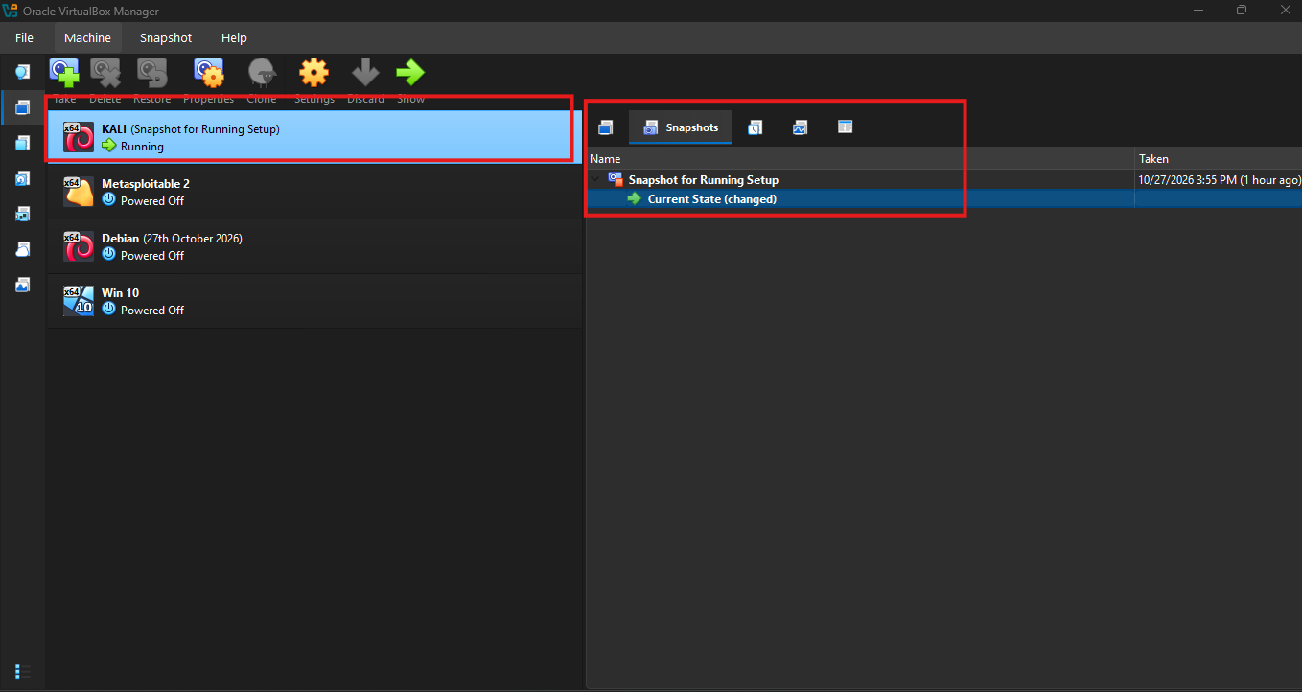
Evidence: Snapshots showing the new snapshot after setup

CONCLUSION
The lab meets every requirement in the task, VirtualBox hosts a Kali Linux attacker VM on a 10.0.0.0/24 NAT Network, Kali holds the static address 10.0.0.2/24, host-guest clipboard, drag/drop and shared folder work, and Kali reaches the Internet.

